Maksims Gudima mg21003 CN Lab3

Had the problem with access both in Linux(Ubuntu) virtual machine and Windows. I followed all steps , tried to troubleshot the problem , but there are no real solutions for this problem . Problem seems to be in Access and Certificate , so it doesn’t allow to connect properly .I have attached screens and did what was possible to complete for this lab .Only managed to complete only for local host.
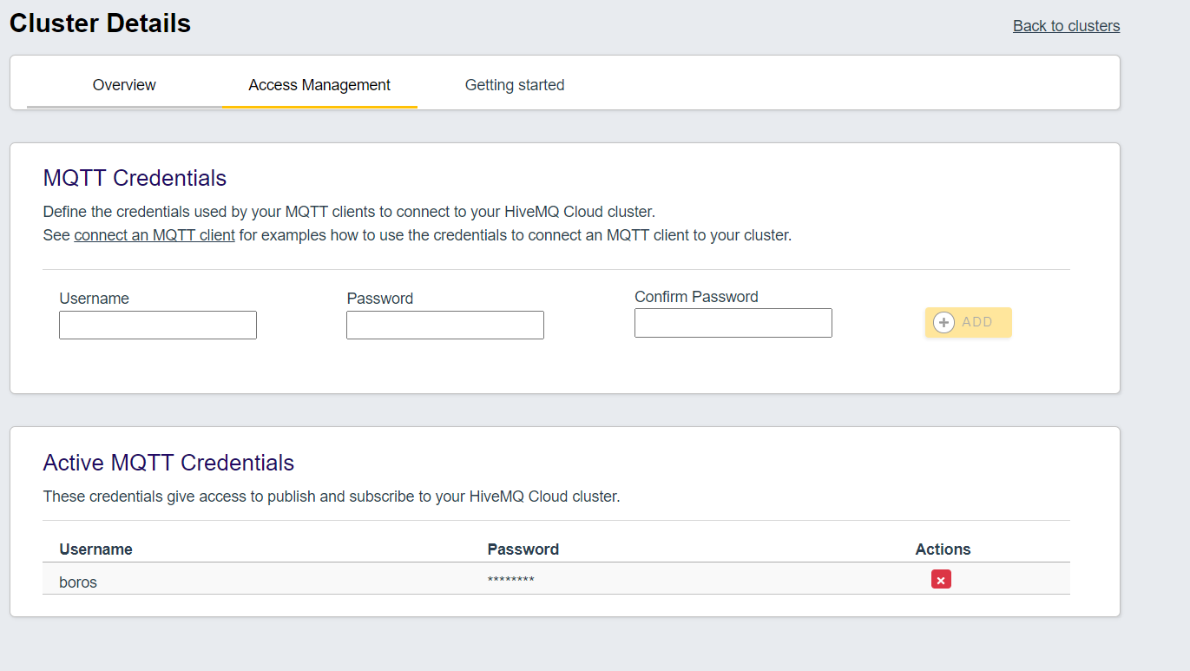
Windows
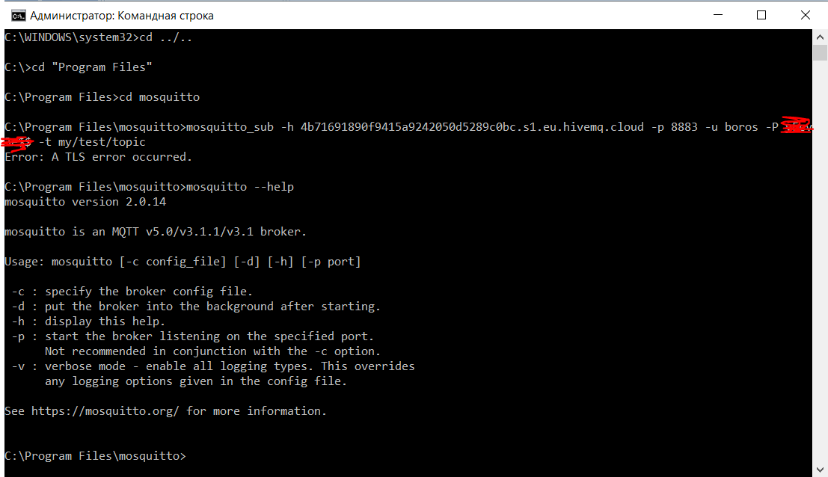
Linux(Ubuntu)
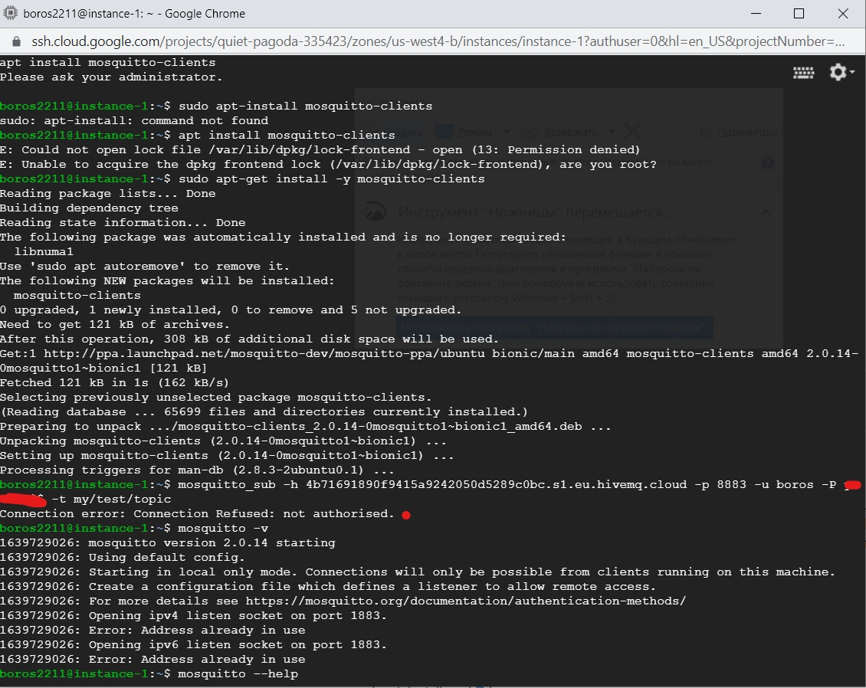

1. Sign up and try out the HiveMQ MQTT brokerage service.

1.1. Familiarize yourself with the web interface for the public HiveMQ MQTT broker.
https://www.hivemq.com/public-mqtt-broker/

1.2. Sign up for the free HiveMQ cloud service page
https://www.hivemq.com/downloads/ (choose "HiveMQ cloud" instead of "Download HiveMQ").

1.3. Follow the instructions to install and test the Mosquitto command line broker .
They can be accessed from the HiveMQ cluster management page as follows: "Manage Clusters" ->
"Getting Started" -> "mosquitto_pub / sub command line tool".
(Attention: if something doesn't work, make sure the installed version of Mosquitto is >=
2.0, as it should be if you follow the instructions exactly.)
Run a `mosquitto_sub` program that listens to all subtopics in a single command line window
in the topic "my".
In the second command line window, post a "Hello" message in the "my/test/topic" topic using
`mosquito_pub` program. In the first window, check that the message is received.

Send the following answers:
1) the exact command to publish the requested message in the previously created HiveMQ environment;
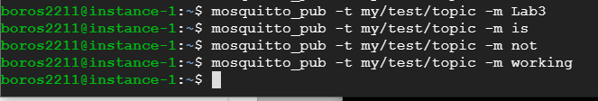
2) the exact command for listening to all "my" sub-topics in the previously created HiveMQ environment.

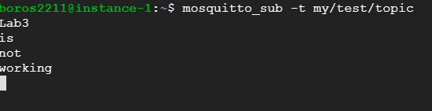
2. Using the Mosquitto command line software installed in the point 1.3. above, sign in to
Mosquitto’s public test broker as described at 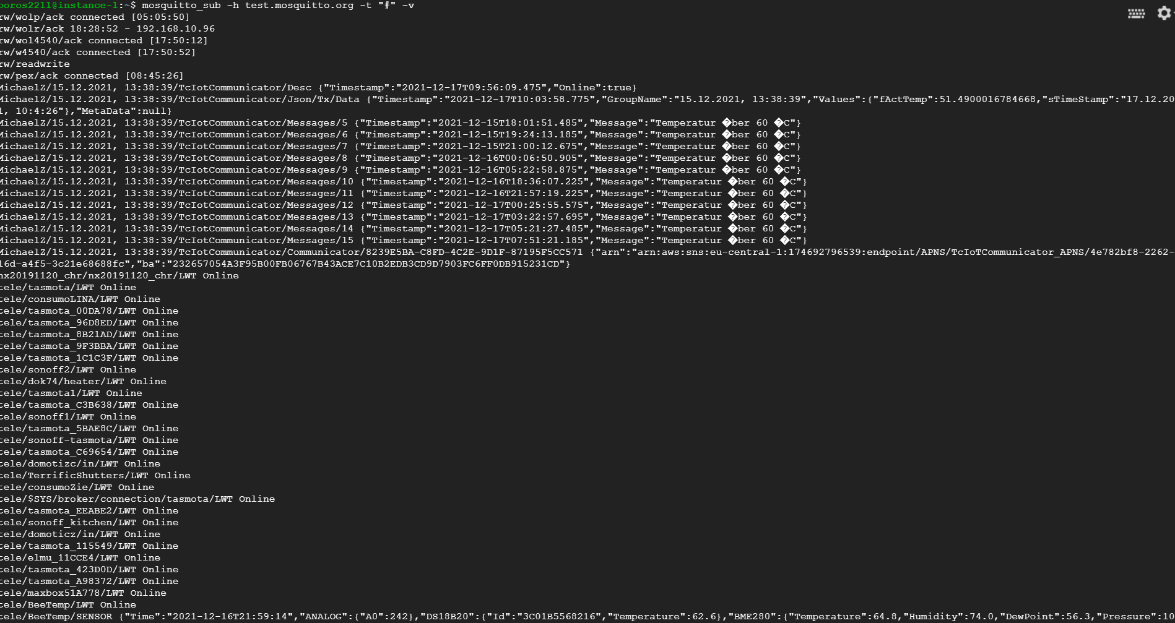
I was getting approximately 400-500 messages in 1 second
Send answers to these questions:
2.1. How many messages per second (approximately) are sent by this broker?
Explanation: This can be appreciated by subscribing to all messages, receiving results for a few seconds, and then estimating the number of results (lines) divided by the duration of the experiment in seconds.
An exact answer is not required, if only because of the volume of activity in this public service
constantly changing. In your answer, write down the clock time you took the measurement.
2.2. What are the two top three topics in this broker?
Explanation: For example, if the following results are observed in the results obtained, then summarize information, the most popular topic is "/ topic1".
/tele/tasmota
/MichaelZ/15.12.2021
/dingtian
/ragdah-11773693

